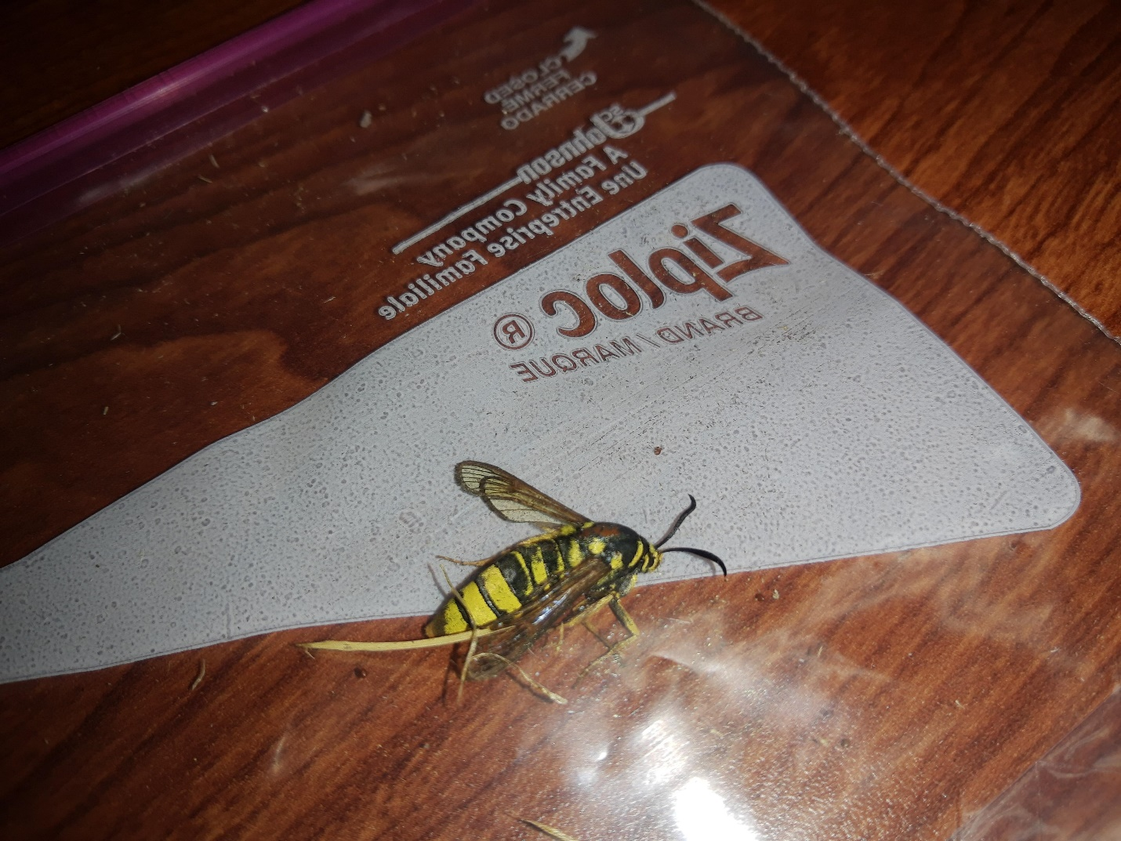
Found at 1890 E Johns Prairie Rd, Shelton WA 98584
Marlene.Smith723@gmail.com

